NAME. : LALITHA

ROLL NO. : 25A31A0111

BRANCH. : CIVIL.

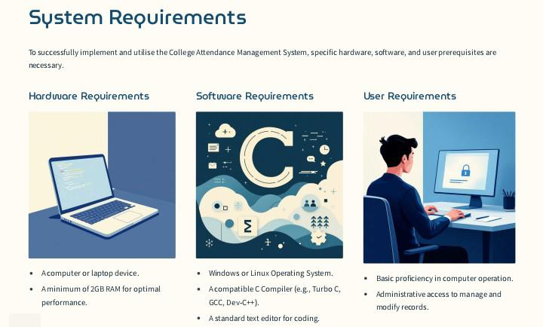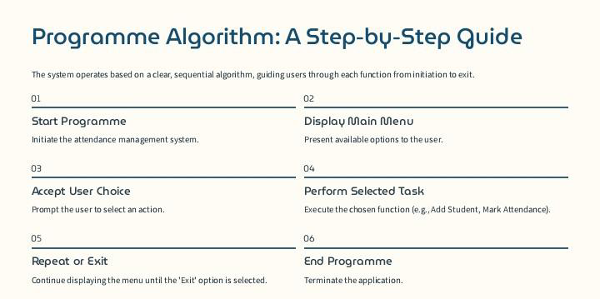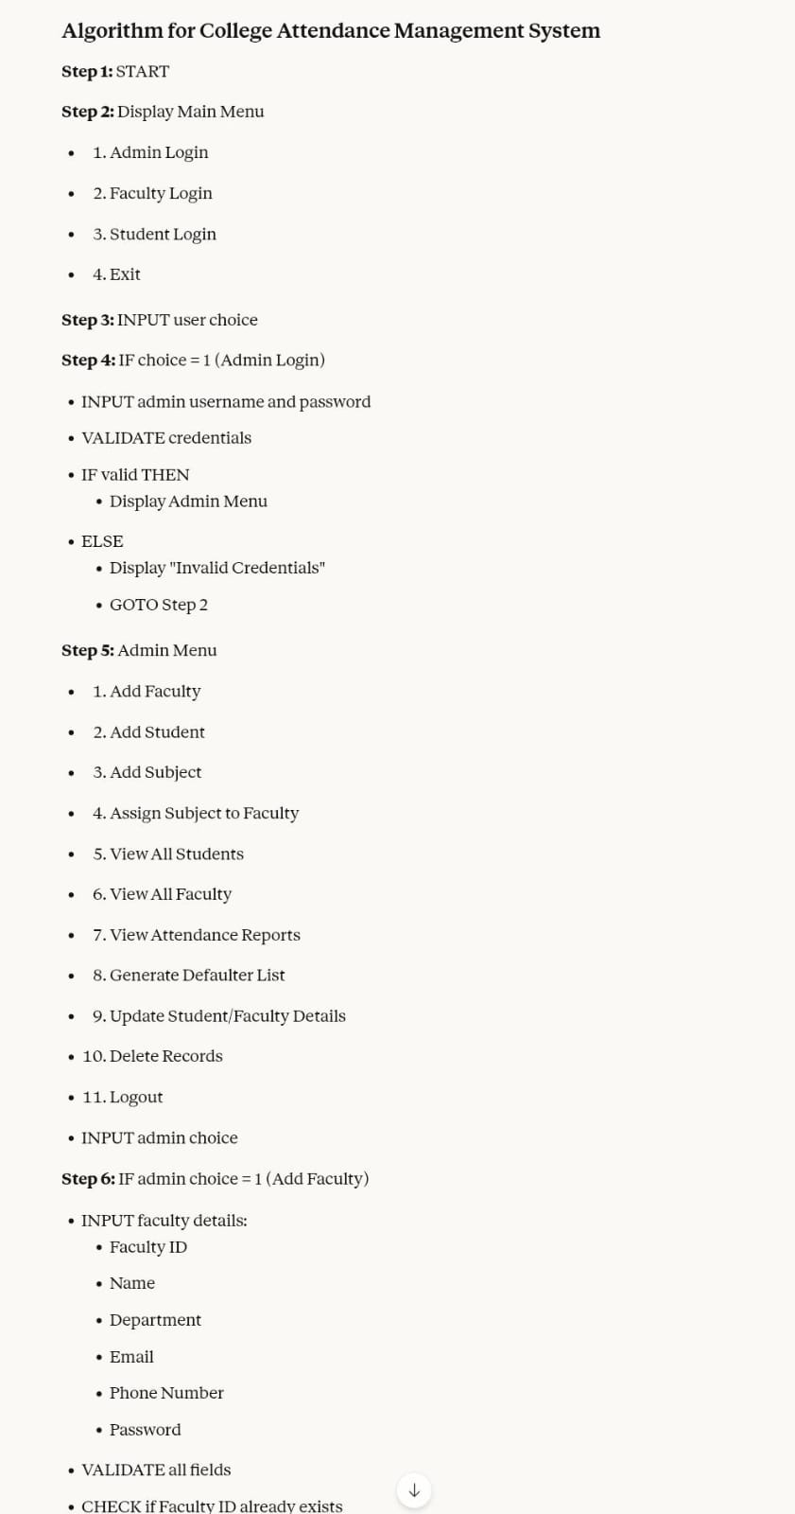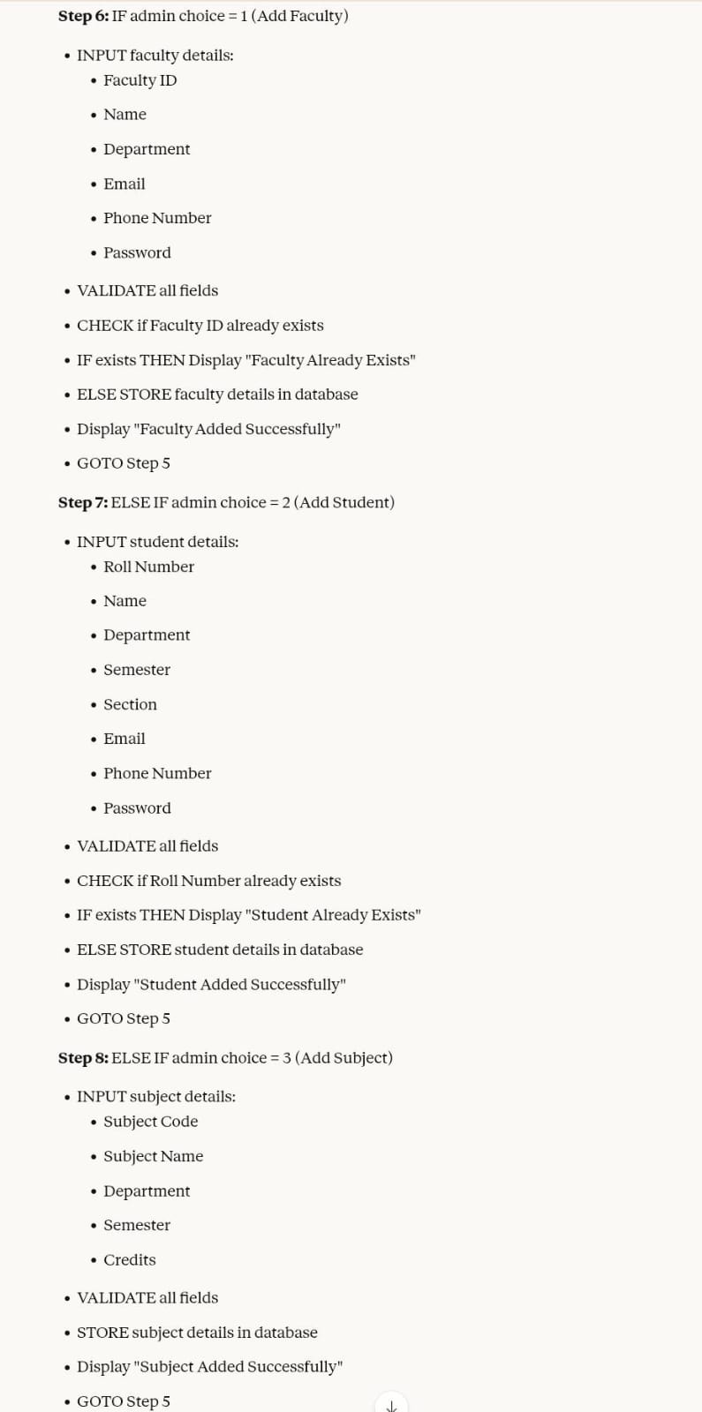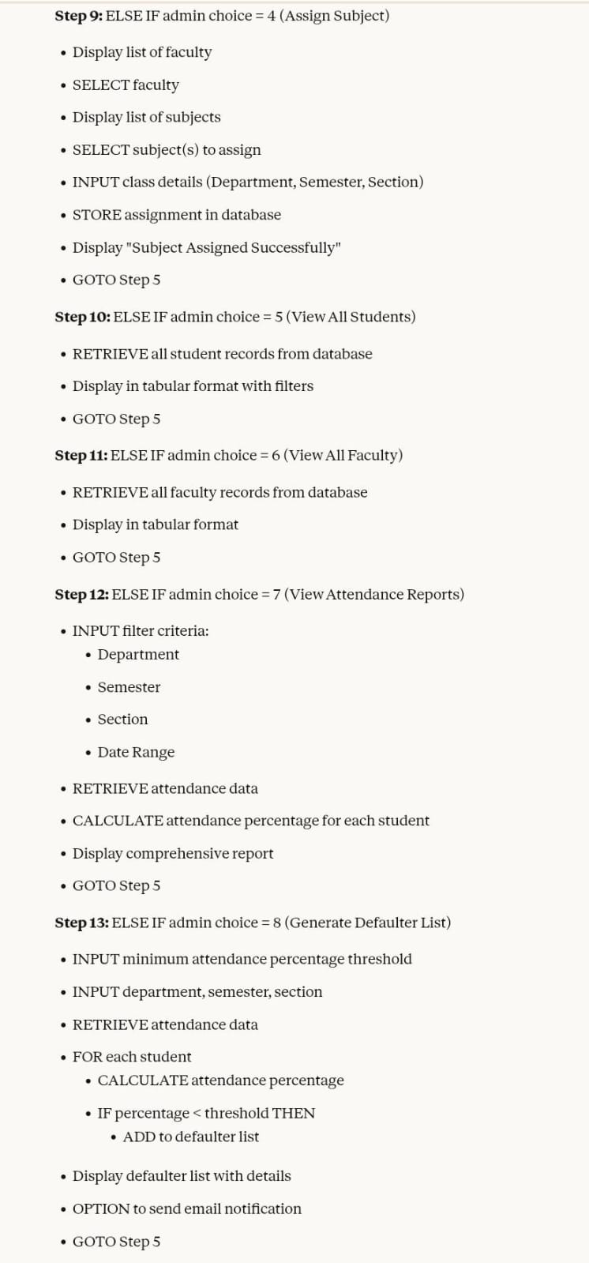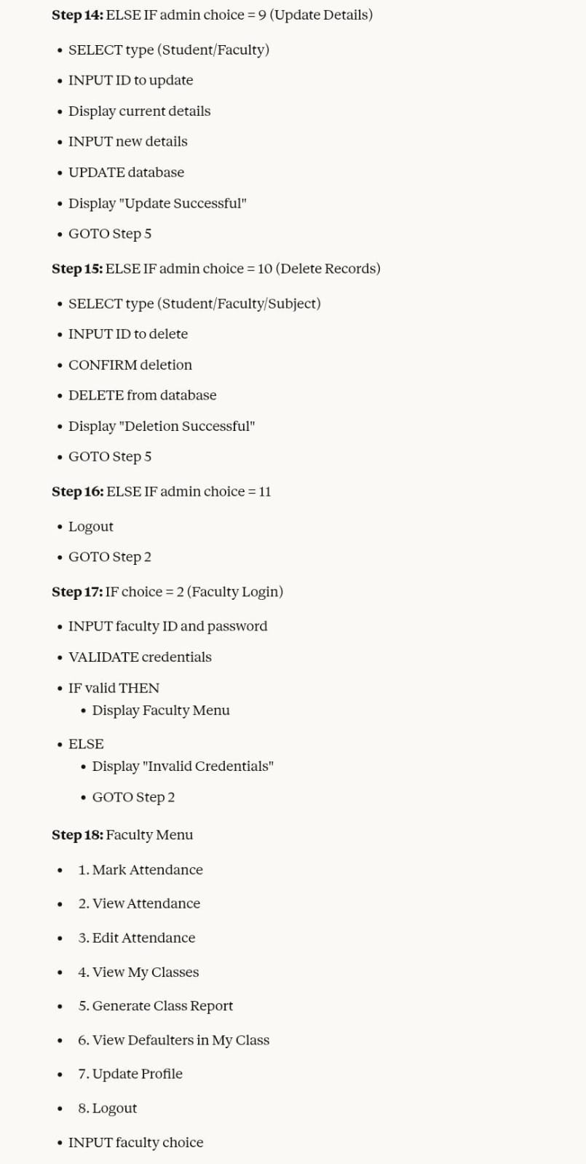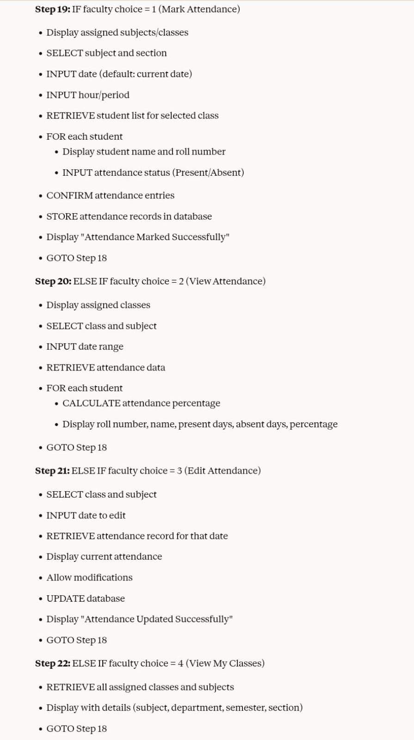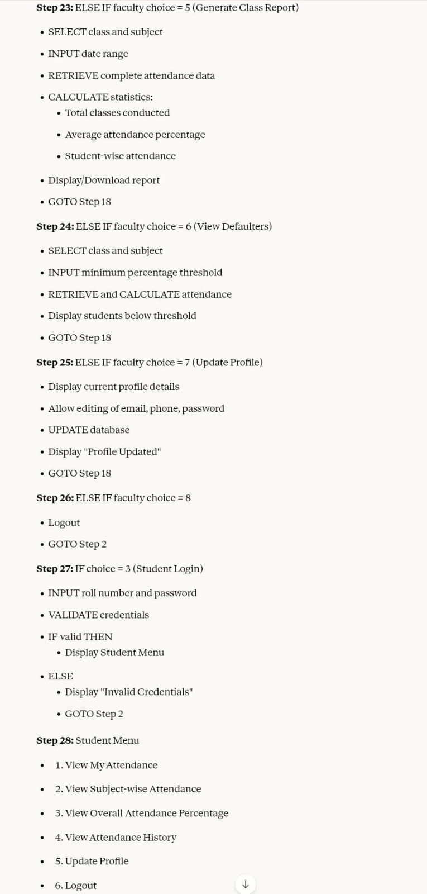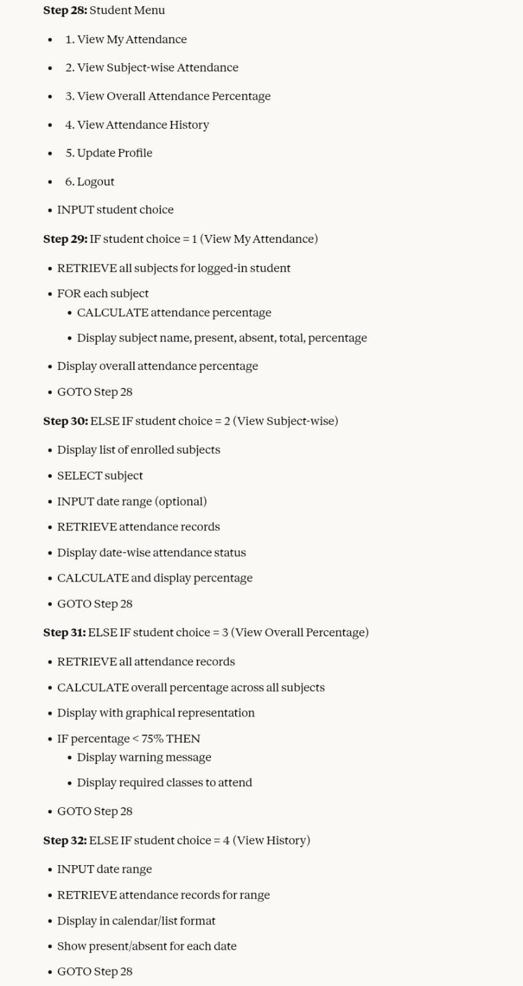

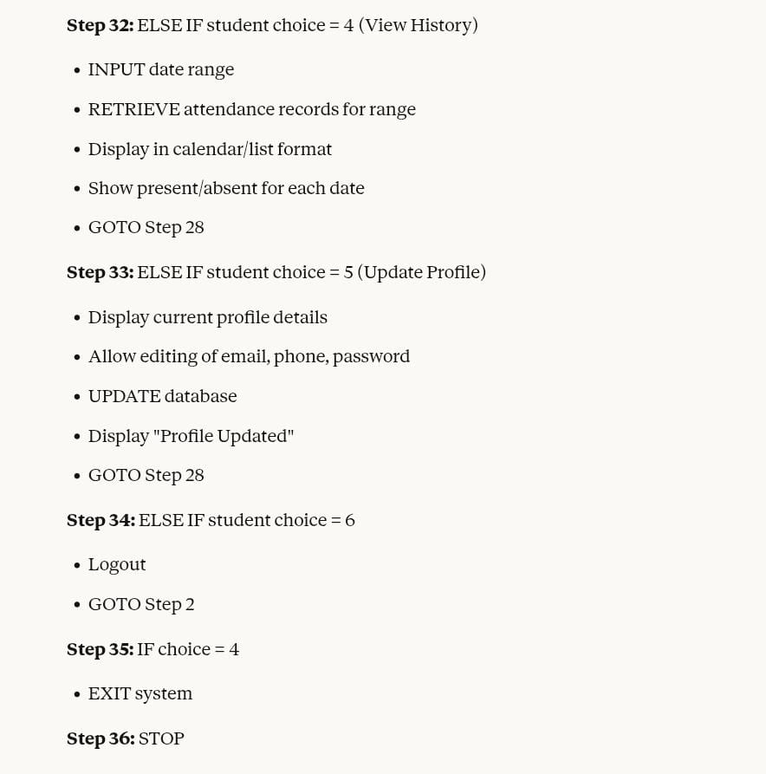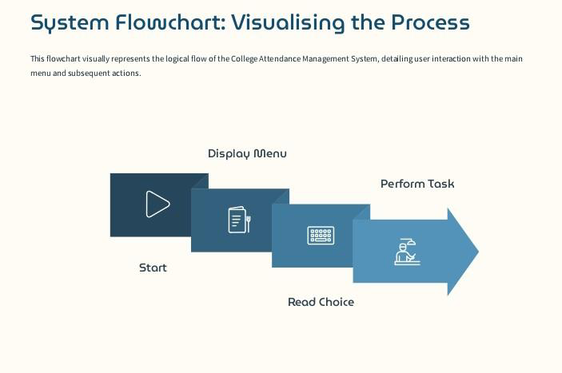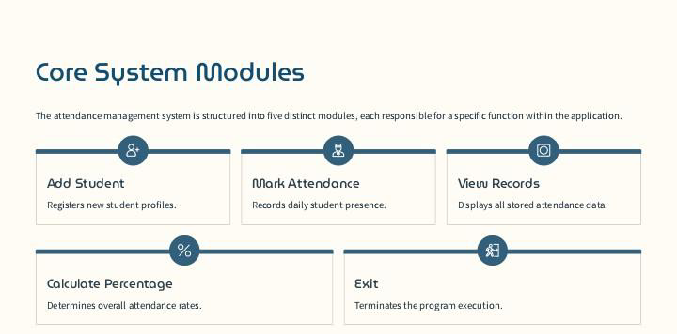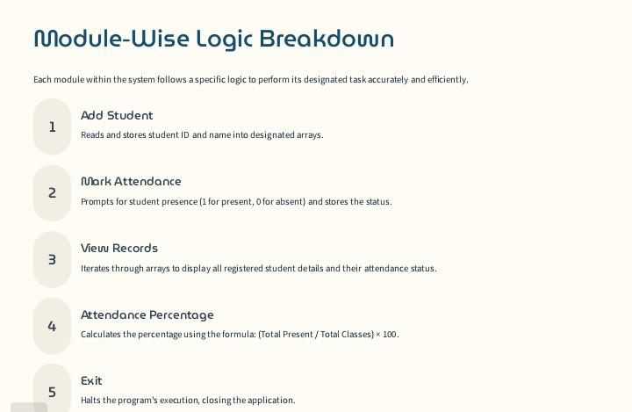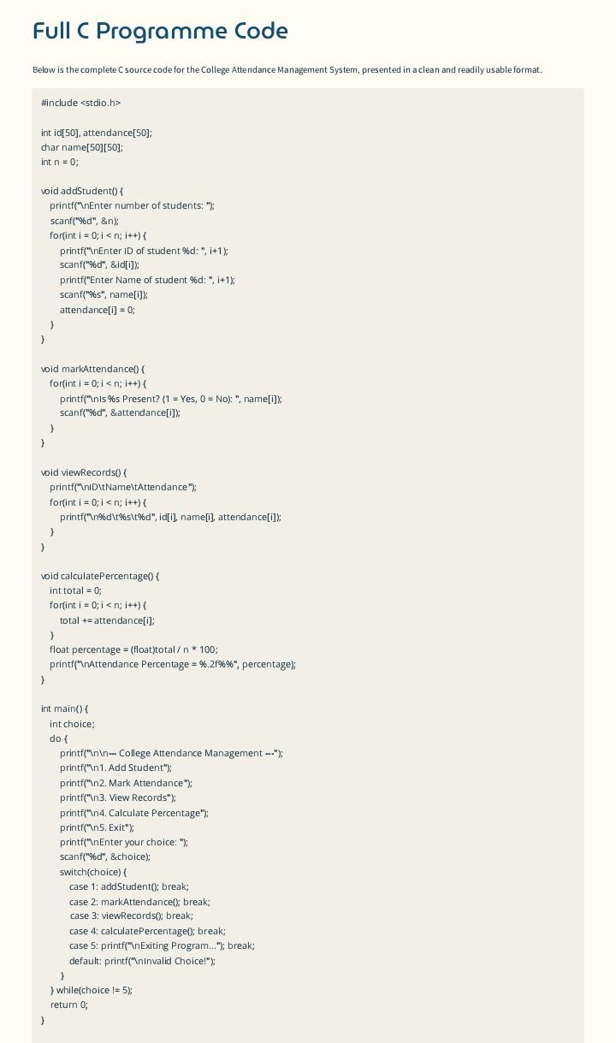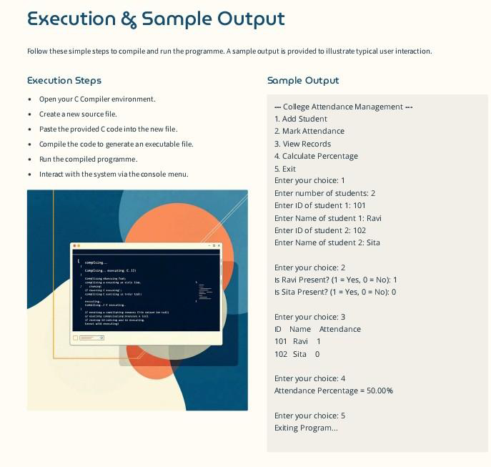

FULL C PROGRAM ::

::

#include <stdio.h>

#include <string.h>

struct Student {

    int roll;

    char name[30];

    int present;

    int total;

};

struct Faculty {

    int id;

    char name[30];

};

struct Student students[5] = {

    {101, "Ravi", 0, 0},

    {102, "Sita", 0, 0},

    {103, "Aman", 0, 0},

    {104, "Neha", 0, 0},

    {105, "Kiran", 0, 0}

};

struct Faculty faculty = {1001, "Mr. Kumar"};

int main() {

    int choice, i, status;

    int adminUser = 1234, adminPass = 1111;

    int facUser = 1001, facPass = 2222;

    int stuRoll, stuPass = 3333;

    printf("\n===== COLLEGE ATTENDANCE MANAGEMENT SYSTEM =====\n");

    printf("1. Admin Login\n");

    printf("2. Faculty Login\n");

    printf("3. Student Login\n");

    printf("4. Exit\n");

    printf("Enter Choice: ");

    scanf("%d", &choice);

    // ================= ADMIN ====================

    if (choice == 1) {

        int u, p;

        printf("Enter Admin Username: ");

        scanf("%d", &u);

        printf("Enter Password: ");

        scanf("%d", &p);

        if (u == adminUser && p == adminPass) {

            printf("\nAdmin Login Successful\n");

            printf("Students List:\n");

            for (i = 0; i < 5; i++)

                printf("%d  %s\n", students[i].roll, students[i].name);

        } else {

            printf("Invalid Admin Login\n");

        }

    }

    // ================= FACULTY ====================

    else if (choice == 2) {

        int u, p;

        printf("Enter Faculty ID: ");

        scanf("%d", &u);

        printf("Enter Password: ");

        scanf("%d", &p);

        if (u == facUser && p == facPass) {

            printf("\nFaculty Login Successful\n");

            printf("1. Mark Attendance\n2. View Attendance\n");

            printf("Enter Choice: ");

            scanf("%d", &choice);

            // MARK ATTENDANCE

            if (choice == 1) {

                for (i = 0; i < 5; i++) {

                    printf("\nRoll %d - %s (1=Present,0=Absent): ",

                           students[i].roll, students[i].name);

                    scanf("%d", &status);

                    students[i].total++;

                    if (status == 1)

                        students[i].present++;

                }

                printf("\nAttendance Marked Successfully\n");

            }

            // VIEW ATTENDANCE

            else if (choice == 2) {

                printf("\nRoll   Name     Present  Total  Percentage\n");

                for (i = 0; i < 5; i++) {

                    float per = (float)students[i].present / students[i].total \* 100;

                    printf("%d  %s     %d      %d     %.2f%%\n",

                           students[i].roll,

                           students[i].name,

                           students[i].present,

                           students[i].total,

                           per);

                }

            }

        } else {

            printf("Invalid Faculty Login\n");

        }

    }

    // ================= STUDENT ====================

    else if (choice == 3) {

        printf("Enter Roll Number: ");

        scanf("%d", &stuRoll);

        printf("Enter Password: ");

        scanf("%d", &status);

        if (status == stuPass) {

            for (i = 0; i < 5; i++) {

                if (students[i].roll == stuRoll) {

                    float per = (float)students[i].present / students[i].total \* 100;

                    printf("\nStudent Name: %s", students[i].name);

                    printf("\nPresent: %d", students[i].present);

                    printf("\nTotal: %d", students[i].total);

                    printf("\nPercentage: %.2f%%\n", per);

                    if (per < 75)

                        printf("WARNING: Attendance Below 75%%\n");

                }

            }

        } else {

            printf("Invalid Student Login\n");

        }

    }

    // ================= EXIT ====================

    else if (choice == 4) {

        printf("Exiting System...\n");

    }

    else {

        printf("Invalid Choice\n");

    }

    return 0;

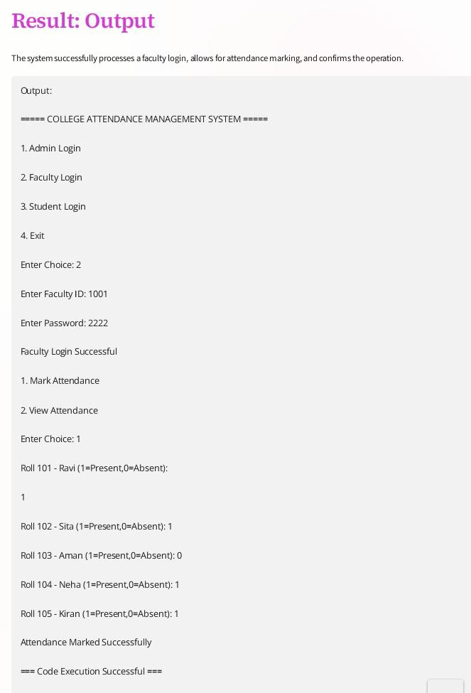

Conclusion:

The College Attendance Management

System provides an efficient and reliable

method for recording, managing, and

monitoring student attendance. By

replacing traditional manual processes

with a digital solution, it reduces errors, saves time, and improves accuracy. This system helps faculty easily track

attendance, generate reports, and

analyze student performance. It also

enhances transparency and supports

better communication between students

and teachers. Overall, the system

contributes to improved academic

management and ensures a smoother, more organized attendance process in the college.

Thank you 👍